|  |
| --- |
| WANDER pRODUCTIONS |
| Dragon’s Nest |
| **COMP305 Assignment 1** |
| Version #1.0  All work Copyright © 2016 by WANDER Procuctions.  All rights reserved. |
| **Arlina Ramrattan** |
|  |

**Insert a Company Logo here**

|  |
| --- |
| October 6, 2016 |

Contents

Version History 3

Github Repository: 3

Game Design 4

Game Overview 4

Camera 4

Controls 4

Interface Sketch 4

Menu and Screen Descriptions 4

Menu Scene 4

Game Scene 5

Game Over Scene 5

Characters 5

Enemies 5

Scoring 5

Sound Index 5

Art / Multimedia Index 6

# Version History

Github Repository: <https://github.com/aramrattan/COMP305-Assignment-1>

# Game Design

## Game Overview

*The goal of this game is to help the dragon (player avatar) collect as many of their lost eggs as possible while avoiding collisions with the birds.*

## Camera

*Orthographic.*

## Controls

*Mouse moves player’s avatar left and right at the bottom of the screen.*

## Interface Sketch

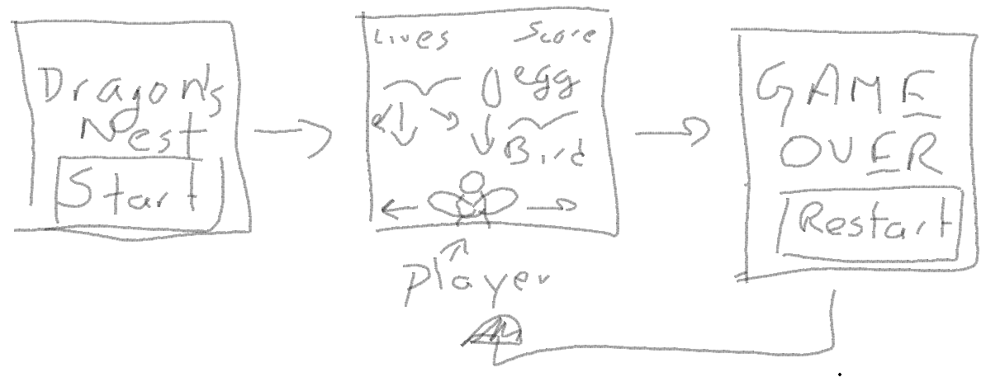

## Menu and Screen Descriptions

### Menu Scene

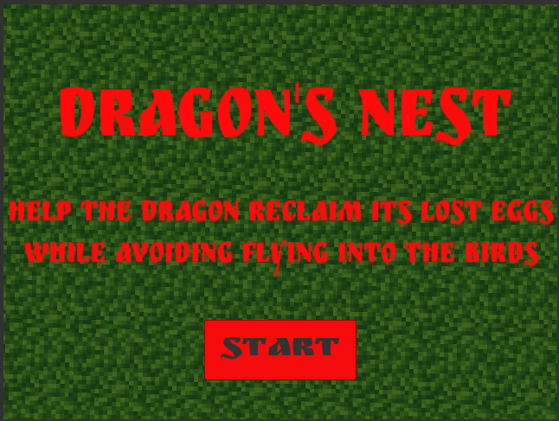

### Game Scene

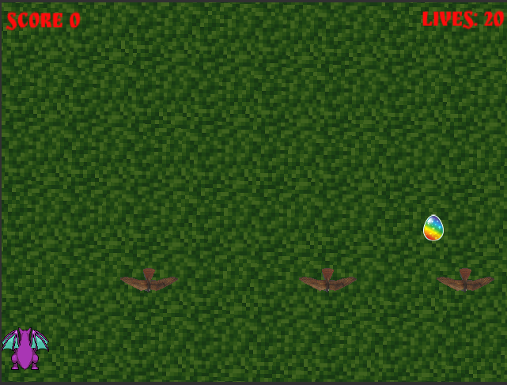

### Game Over Scene

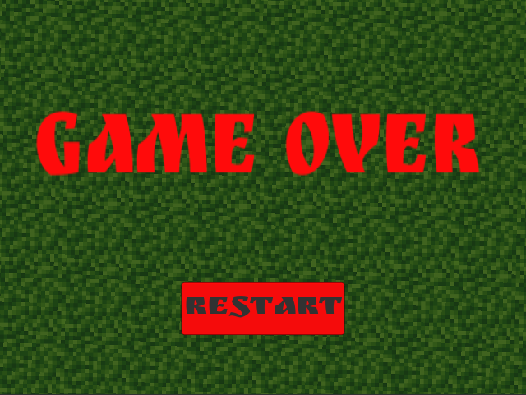

## Characters

The player avatar is a flying purple dragon

## Enemies

*The enemies are the birds; you collide with one you lose a life.*

## Scoring

* 100 points for collecting 1 egg
* -1 life for every bird hit

## Sound Index

|  |  |
| --- | --- |
| **Name** | **Description** |
| BGMusic.mp3 | Background music for whole game |
| Ow.mp3 | Sound effect when dragon collides with bird |
| Powerup7.wav | Sound effect when dragon gets an egg |
| GameOver.mp3 | Sound effect when player loses all lives |

## Art / Multimedia Index

|  |  |
| --- | --- |
| **Image** | **Description** |
|  | Grass Back Ground |
|  | Player Avatar (dragon) |
|  | Dragon Egg |
|  | Bird (enemy) |
| RuslanDisplay.ttf | Font for verbage |